***How to convert JSON file to CSV file***

I download this JSON file in google

{ "contents": [

{

"category": "Furniture",

"region": "West",

"monthlySales":

[{

"month":20130101,

"sales":38

},

{

"month":20130201,

"sales":35

},

{

"month":20130301,

"sales":41

},

{

"month":20130401,

"sales":55

},

{

"month":20130501,

"sales":58

},

{

"month":20130601,

"sales":66

},

{

"month":20130701,

"sales":74

},

{

"month":20130801,

"sales":78

},

{

"month":20130901,

"sales":38

},

{

"month":20131001,

"sales":30

},

{

"month":20131101,

"sales":26

},

{

"month":20131201,

"sales":29

}

]

},

{

"category": "Technology",

"region": "West",

"monthlySales":

[{

"month":20130101,

"sales":54

},

{

"month":20130201,

"sales":66

},

{

"month":20130301,

"sales":77

},

{

"month":20130401,

"sales":70

},

{

"month":20130501,

"sales":60

},

{

"month":20130601,

"sales":63

},

{

"month":20130701,

"sales":55

},

{

"month":20130801,

"sales":47

},

{

"month":20130901,

"sales":55

},

{

"month":20131001,

"sales":30

},

{

"month":20131101,

"sales":22

},

{

"month":20131201,

"sales":77

}

]

}

]}

**Solution :-**

**Method 1:-**

import json

import csv

with open('C:/Users/SSS2022259/Downloads/archive/monthly_sales.json', 'r') as json_file: # Read the JSON file

data = json.load(json_file) # load json file

csv_file = open('C:/Users/SSS2022259/Downloads/archive/output.csv', 'w', newline='') # Prepare the CSV file

csv_writer = csv.writer(csv_file)

csv_writer.writerow(['category', 'region', 'month', 'sales']) # Write the headers for the CSV file

for content in data['contents']: # Iterate over the 'contents' in the JSON data

category = content['category']

region = content['region']

monthly_sales = content['monthlySales']

for monthly_sale in monthly_sales: # Iterate over the 'monthlySales' list for each content

month = monthly_sale['month']

sales = monthly_sale['sales']

csv_writer.writerow([category, region, month, sales]) # Write the data to the CSV file

csv_file.close()

**Output:-**

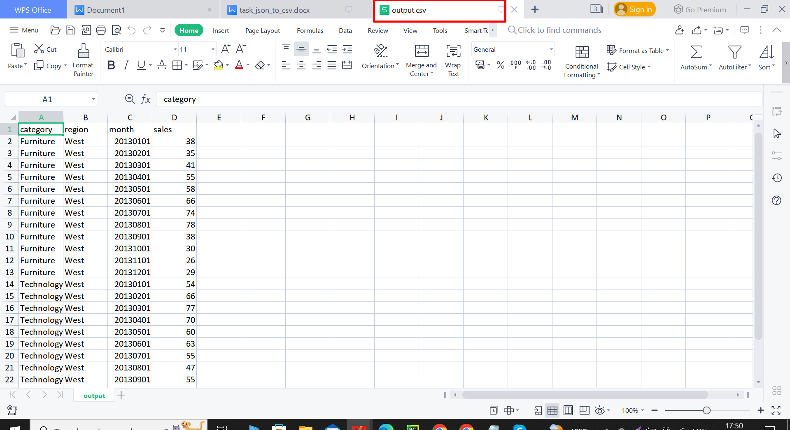

**Method2:-**

import pandas as pd

import json

def flatten_array(array):

if isinstance(array, list):

return [item for sublist in array for item in flatten_array(sublist)]

else:

return [array]

# Load the JSON file

with open('C:/Users/SSS2022259/Downloads/archive/monthly_sales.json', 'r') as f:

data = json.load(f)

# Extract and flatten the 'monthlySales' array

nested_array = flatten_array([content['monthlySales'] for content in data['contents']])

# print(nested_array)

# Append 'contents' data to each row of the 'monthlySales' array

combined_data = []

for content in data['contents']:

monthly_sales = content['monthlySales']

combined_data.extend([{

**content,

**monthly_sale

} for monthly_sale in monthly_sales])

# Convert the combined data to a pandas DataFrame

df = pd.DataFrame(combined_data)

df = df.drop(columns=['monthlySales'])

# Convert the DataFrame to a CSV file

df.to_csv('C:/Users/SSS2022259/Downloads/archive/newoutput.csv')

**Output:-**

